### Saudi Tourism Authority

Saudi Rewards - Membership Tiers Page

November 2023

**Membership Tiers Page**

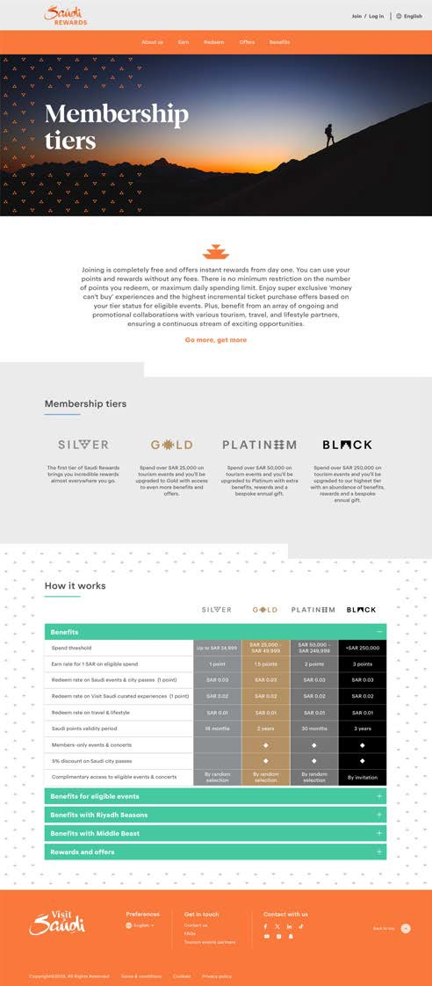

[header component]

[H1] Membership tiers

[intro component]

[body text]

Rewards from day one. Free membership. No fees, minimum spending threshold or daily spending limit — and that’s just the starting tier of Saudi Rewards. Members in all tiers can access “money can’t buy” experiences, ticket discounts for eligible events, exclusive offers and deal from travel and lifestyle partners, and a never-ending stream of exciting rewards.

It only gets better with every tier.

Go more, get more.

[column component]

[H2] Membership Tiers

[column 1]

[Silver Tier Logo]

[body text] Start at Silver and earn points, benefits and offers from the moment you sign up. It’s free to join and only gets better the further you go.

[column 2]

[Gold Tier Logo]

[body text] Advance to Gold once you spend SAR25,000 on eligible purchases. At this level, you’ll earn 1.25 Saudi points for every SAR1 spent, and your points remain valid for 24 Months.

[column 3]

[Platinum Tier Logo]

[body text] Reach Platinum once you spend SAR50,000 on eligible purchases. At this level, you’ll earn 1.5 Saudi points for every SAR1 spent, and your points remain valid for 30 Months.

[column 4]

[Black Tier Logo]

[body text] Achieve Black status once you spend SAR250,000 on eligible purchases. At this elite level, you’ll earn 2 Saudi points for every SAR1 spent, and your points remain valid for 36 Months.

[chart component]

[H2] How It Works

|  |  |  |  |  |  |
| --- | --- | --- | --- | --- | --- |
| [H3] Rewards Overview | | [Silver Tier Logo] | [Gold Tier Logo] | [Platinum Tier Logo] | [Black Tier Logo] |
| Up to SAR24,999 | SAR25,000 to SAR49,999 | SAR50,000 to SAR249,999 | SAR250,000+ |
| Points earned for every SAR1 spent | | 1 Saudi Point | 1.5Saudi Points | 2 Saudi Points | 3 Saudi Points |
| Redemption value per Saudi Point | Events and curated tourism experiences | SAR0.02 | SAR0.02 | SAR0.02 | SAR0.02 |
| Travel and lifestyle purchase | SAR0.01 | SAR0.01 | SAR0.01 | SAR0.01 |
| Validity period of Saudi Rewards points | | 18 Months | 24 Months | 30 Months | 36 Months |
| Members-only events and concerts | | ⬩ | ⬩ | ⬩ | ⬩ |
| 5% Discount on Saudi City Passes | | ⬩ | ⬩ | ⬩ | ⬩ |
| Complimentary access to eligible events & concerts | | By random selection | By random selection | By random selection | By invitation |

|  |  |  |  |  |
| --- | --- | --- | --- | --- |
| [H3] Rewards for Eligible Events  (MDLBEAST-Soundstorm) | [Silver Tier Logo] | [Gold Tier Logo] | [Platinum Tier Logo] | [Black Tier Logo] |
| Complimentary access to eligible Events | ⬩ | ⬩ | ⬩ | ⬩ |
| Pre-launch booking access for events tickets |  |  | ⬩ | ⬩ |
| 20% discount on Tickets | ⬩ | ⬩ | ⬩ | ⬩ |
| 15% discount on Merchandise | ⬩ | ⬩ | ⬩ | ⬩ |
| Raffle draw on 10 VIP Balconas | ⬩ | ⬩ | ⬩ | ⬩ |
| Raffle draw on rooms in Intercontinental Hotel |  |  | ⬩ | ⬩ |
| Raffle draw for VIP Box tickets |  |  | ⬩ | ⬩ |
| Complimentary General admission tickets |  |  | By Invitation | By Invitation |
| Demarcated parking at Events for VIP tickets |  | ⬩ | ⬩ | ⬩ |
| Shuttle service between parking area and entrance |  | ⬩ | ⬩ | ⬩ |
| Dedicated gate for Fast track entrance |  | ⬩ | ⬩ | ⬩ |
| Her Experience zone dedicated for females |  | ⬩ | ⬩ | ⬩ |
| Exclusive in-event Raffle Draws and/or Grand Prizes | ⬩ | ⬩ | ⬩ | ⬩ |
| Raffle Draw for Meet & Greet Influencers and Music Artists | ⬩ | ⬩ | ⬩ | ⬩ |
| Raffle Draw for Backstage Access to Music Artists | ⬩ | ⬩ | ⬩ | ⬩ |



SEO

Meta Title: Compare Membership Tiers | Saudi Rewards

Meta Description: Find a Saudi Rewards membership tier that works for you. From car rentals to member-only events, discover the discounts that make your trip smoother.

URL: /en/membership-tiers